3+3 Program Participation Form – George Mason University | 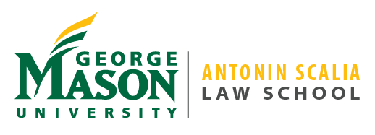

Contact Information
Full Name
Street Address
City, State Zip
Phone
G#
E-Mail Address

Bachelor’s Degree
Your proposed major: ________________________________________________________________
Your undergraduate college or program: _________________________________________________
Your non 3+3 anticipated graduation term (ie: Spring 2021): ________________
Name & Authorizing Signature of Major Advisor:

__________________________________________________________________________________

Name & Authorizing Signature of Honors College Advisor (if applicable):

__________________________________________________________________________________

Your Juris Doctorate Interests

Indicate your interest in any of these legal concentrations, if any:
Antitrust Law | Communications Law
Corporate and Securities Law | Criminal Law
___ Immigration Law | Intellectual Property Law
International Business Law | Legal and Economic Theory
Litigation | National Security Law & Policy
Personal Law | ___ Public Interest Litigation & Advocacy
Regulatory Law | ___ Sports Law
Tax Law | Technology Law
General Law

3+3 Program Description & Requirements
The 3+3 Program offers highly motivated students a fast track to a law degree in six, rather than seven, years of study. Students pursuing the program must complete all core curriculum and major specific courses of their undergraduate education by the end of the sixth semester of undergraduate study; take the LSAT no later than November of the final undergraduate year and obtain an LSAT score equal to or exceeding the median LSAT of the preceding year for Scalia Law students; maintain a minimum cumulative undergraduate GPA as calculated by the Law School Admission Council of 3.25; submit the entire law school application through the Law School Admission Council by January 1 of the year in which the student desires to enroll in the law school; and complete an interview with the admissions staff of the law school.

Why 3+3

Briefly tell us why you are interested in the 3+3 Program.

Agreement and Signature

By submitting this form, I am indicating my interest in pursuing the 3+3 Program at George Mason University. I understand that by indicating my interest in the accelerated program, I am not obligated to complete the 3+3 program, to attend Scalia Law, or to attend any other law school. I understand that if I do desire to fully participate in and complete this accelerated program, I must complete all of the requirements for eligibility for admission to the law school.
Name (printed)
Signature
Date

Submit To:

By mail: Office of Admissions
George Mason University Antonin Scalia Law School
3301 Fairfax Drive, MS 1G3
Arlington, VA 22201
Or
By pdf to: lawadmit@gmu.edu

